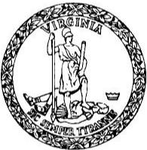 | BLYTHE A. SCOTT  COMMISSIONER OF THE REVENUE  P.O. BOX 2260 NORFOLK, VIRGINIA 23501-2260 | 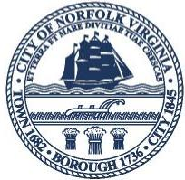

Dear Event Organizer,
The Commissioner of the Revenue office would like to take this opportunity to share some important information regarding food and merchandise vendors who wish to participate in special events in Norfolk. Special events are defined as an activity such as a show, exhibit of any kind, convention, parade, festival, circus, sporting event, fair or carnival, held for a limited period at a specific location, Sec. 42-36(j) - Norfolk Municipal Code.
Just as established businesses, vendors, must be licensed when selling food or merchandise at special events (Sec 42-39).
Please be advised of the following guidelines of this office and other regulations as defined in our City Code:
- All businesses and individuals must have a valid Norfolk business license to participate in events in Norfolk. Norfolk City Code, Sec. 24-25.3
- All businesses and individuals applying for a license or who have a business license must be current and remain current on all taxes, including real estate, personal property, business license, food & beverage tax, room & lodging tax, etc. Norfolk City Code, Sec. 24-25.10
- Please allow as much advance notice of your event as soon as possible to allow vendors ample time to obtain their license or satisfy any past due tax obligations to the city.
- Upon notification of the event taking place, please provide a vendor list. Please use the attached spread sheet to provide vendor information. This sheet can be provided electronically via our email address, CORBT@NORFOLK.GOV.
- Vendor participation is based on an agreement between the event sponsor and the participant. The Commissioner of the Revenue office is only responsible for issuing a special event business license to those who apply and receive approval from the Norfolk City Treasurer.

To ensure business licenses are in hand the day of the event, ALL applications must be submitted, and payments received 7 business days prior to the scheduled event.
Event organizers and non-profit organizations usually do not require a special event business license, but please confirm with our office before the event takes place.
We look forward to working with you to make your vendors’ experience in Norfolk a great one. If you have any questions or concerns, please call this office at (757) 664-7886.

Very truly yours,
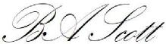
Norfolk Commissioner of the Revenue

757.664.7890 | NORFOLKCOR@NORFOLK.GOV | WWW.NORFOLK.GOV/REVENUE

